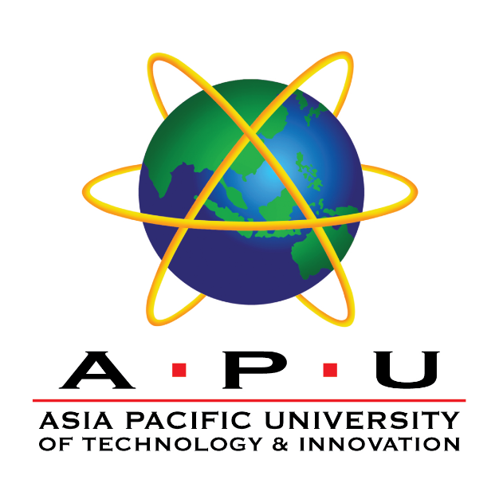

**DDAC INDIVIDUAL ASSIGNMENT**

Name: Lambert Kok Zhao Xiong

Student ID: TP035025

Intake Code: UC3F1706SE

Module: Designing and Developing Applications on the Cloud

(CT071-3-3-DDAC)

Project Title: Maersk Line Container Management System (CMS)

Lecturer: Dr. Kalai Anand A/L Ratnam

Date Assigned: 11 December 2017

Date Completed: 13 March 2018